**Assignment -4**

# SMS SPAM Classification

|  |  |
| --- | --- |
| Assignment Date | 08 NOVEMBER 2022 |
| Team id | PNT2022TMID46647 |
|  |  |
| Maximum Marks | 2 Marks |

**Question-1:**

## Download the dataset

**Question-2:**

Import required library **Solution** import nltk import pandas as pd import re

from nltk.corpus import stopwords from nltk.stem.porter

import PorterStemmer from sklearn.feature_extraction.text import CountVectorizer from sklearn.model_selection import train_test_split from tensorflow.keras.models import

Sequential from tensorflow.keras.layers import Dense

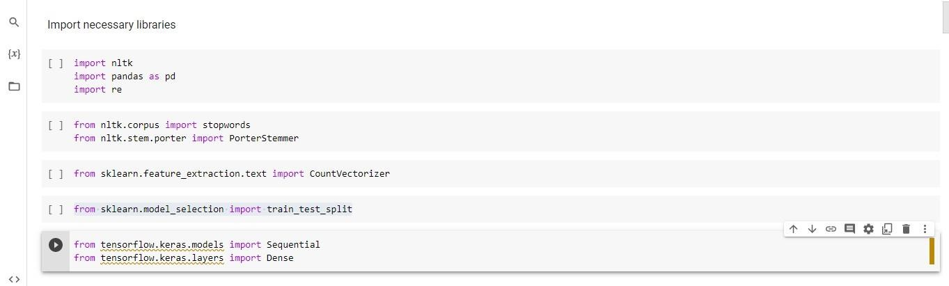

**Question-3:**

## Read dataset and do pre-processing

**Solution**

data=pd.read_csv('/content/drive/MyDrive/assignment 4/spam.csv',encoding='latin')

nltk.download('stopwords') ps=PorterStemmer() input=[] for i in range(0,5572):

review=data['v2'][i] review=re.sub('[^a-zA-Z]',' ',review)

review=review.lower() review=review.split() review=[ps.stem(word) for word in review

if not word in set(stopwords.words('english'))] review=' '.join(review) input.append(review) cv=CountVectorizer(max_features=7000) x=cv.fit_transform(input).toarray() y=data['v1'].values x_train,x_test,y_train,y_test= train_test_split(x,y,test_size=0.2)

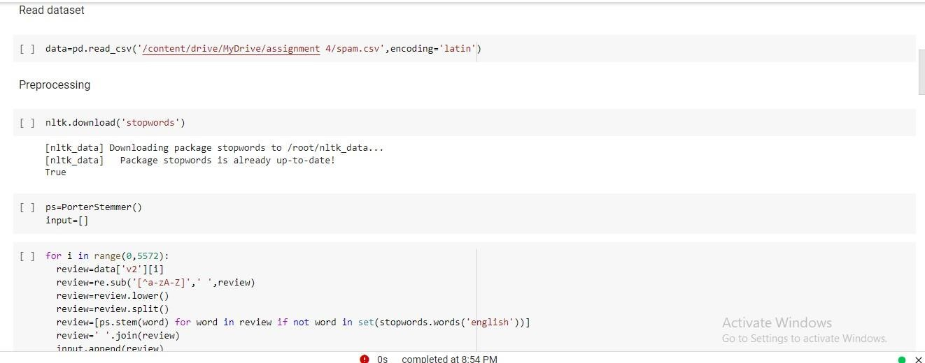

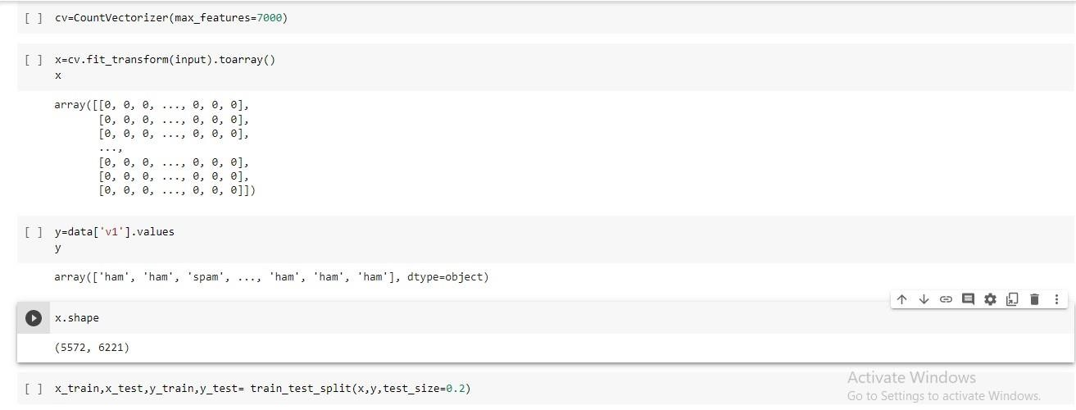

**Question-4:**

## Create Model

**Solution**  model=Sequential()

**Question-5:**

Add Layers (LSTM, Dense-(Hidden Layers), Output) **Solution** model.add(Dense(units=6221,activation='relu')) model.add(Dense(units=7000,activation='relu')) model.add(Dense(units=1,activation='sigmoid'))

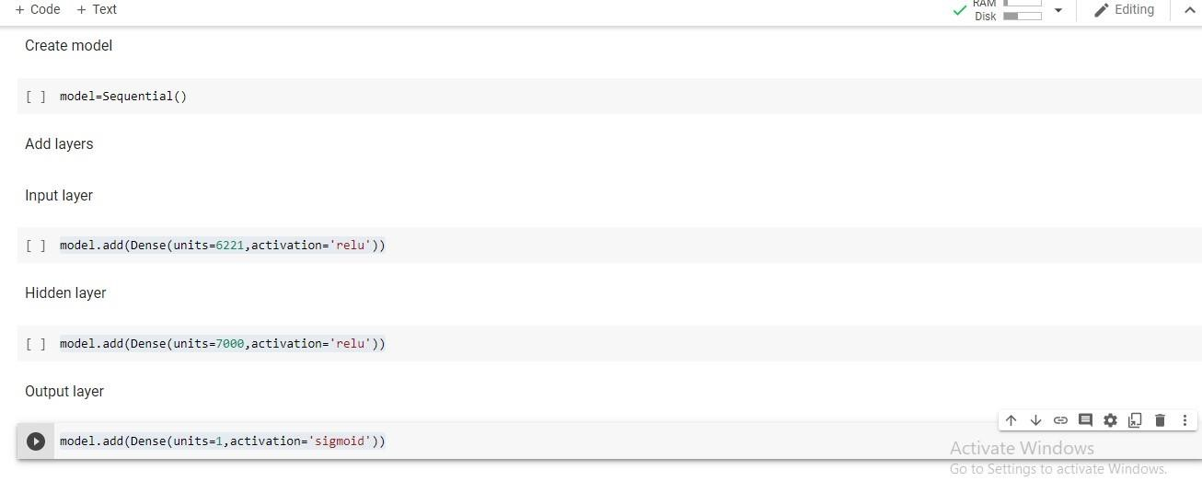

**Question-6:**

Compile The Model **Solution**  model.compile(optimizer='adam',loss='binary_crossentropy',metrics=['accuracy'])

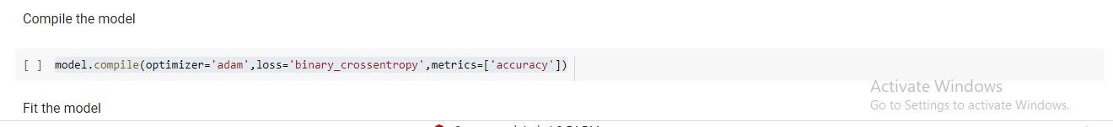

**Question-7:**

Fit The Model **Solution**  model.fit(x_train,y_train,epochs=5)



**Question-7:**

Save The Model **Solution**  model.save("Flowers.h5")

